**DAILY ONLINE ACTIVITIES SUMMARY**

|  |  |  |  |  |  |  |  |  |  |
| --- | --- | --- | --- | --- | --- | --- | --- | --- | --- |
| **Date:** | **30/06/2020** | | | | | **Name:** | | **NAIPUNYA VINOD NAIK** | |
| **Sem & Sec** | **IV SEM & A SECTION** | | | | | **USN:** | | **4AL18CS050** | |
| **Online Test Summary** | | | | | | | | | |
| **Subject** | | **NO INTERNALS CONDUCTED** | | | | | | | |
| **Max. Marks** | | **N/A** | | **Score** | | | | **N/A** | |
| **Certification Course Summary** | | | | | | | | | |
| **Course** | **THE COMPLETE 2019 RASPBERRY PI BOOTCAMP** | | | | | | | | |
| **Certificate Provider** | | | **UDEMY** | | | | **Duration** | | **4.5 HRS** |
| **Coding Challenges** | | | | | | | | | |
| **Problem Statement: 1)** [Write a C++ Program to Move all zeroes to end of array using Two-Pointers](https://github.com/orgs/alvas-education-foundation/teams/2nd-year/discussions/140)  2) [Write a C Program to check whether the number is Ugly or not.](https://github.com/orgs/alvas-education-foundation/teams/2nd-year/discussions/141)  3) [Write a C Program to generate first n Ugly Numbers](https://github.com/orgs/alvas-education-foundation/teams/2nd-year/discussions/142). | | | | | | | | | |
| **Status: EXECUTED** | | | | | | | | | |
| **Uploaded the report in Github** | | | | | **YES** | | | | |
| **If yes Repository name** | | | | | <https://github.com/naipunya-naik/lockdown-coding/blob/master/C%2B%2B%20CODING/Move%20all%20zeroes%20to%20end%20of%20array_30-06-2020.cpp>  <https://github.com/naipunya-naik/lockdown-coding/blob/master/C%20CODING/Ugly%20Or%20Not_30-06-2020.c>  <https://github.com/naipunya-naik/lockdown-coding/blob/master/C%20CODING/Ugly_30-06-2020.c> | | | | |
| **Uploaded the report in slack** | | | | | **YES** | | | | |

Online Test Details: (Attach the snapshot and briefly write the report for the same)

NO INTERNALS CONDUCTED

Certification Course Details: (Attach the snapshot and briefly write the report for the same).



TOPICS COVERED ON 30 JUNE 2020:-

* **Raspberry Pi Basics**

In this course about Raspberry Pi, a credit card sized computer. I explored about the possibilities of Raspberry Pi as a computer and a state of the art control machine.

* **Arduino Vs Raspberry PI Vs PIC Microcontroller**
* **Connect and Interface Raspberry Pi with Arduino**
* **Make a Smart Mirror Using Raspberry Pi**
* **Obstacle Avoiding Robot with Raspberry Pi**

Coding Challenges Details: (Attach the snapshot and briefly write the report for the same).

PROBLEM STATEMENT:- [Write a C++ Program to Move all zeroes to end of array using Two-Pointers](https://github.com/orgs/alvas-education-foundation/teams/2nd-year/discussions/140)

Top of Form

Bottom of Form

|  |
| --- |
| Given an array of random numbers, Push all the zero’s of the given array to the end of the array. For example, if the given arrays is {1, 0, 2, 6, 0, 4}, it should be changed to {1, 2, 6, 4, 0, 0}. The order of all other elements should be the same.  Examples:  Input: arr[]={8, 9, 0, 1, 2, 0, 3} Output: arr[]={8, 9, 1, 2, 3, 0, 0} Explanation: Swap {0 ,1} -> Resulting array {8, 9, 1, 0, 2, 0, 3} Swap {0 ,2} -> Resulting array {8, 9, 1, 2, 0, 0, 3} Swap {0 ,3} -> Final array {8, 9, 1, 2, 3, 0, 0}  Input: arr[]={4, 5, 0, 0, 0, 0, 6, 7} Output: arr[]={4, 5, 6, 7, 0, 0, 0, 0} |

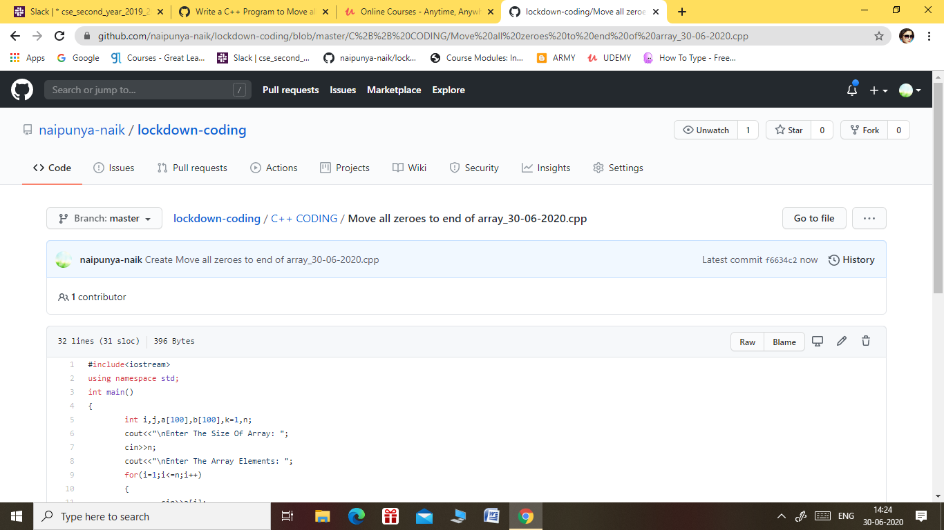

GITHUB REPOSITORY LINK:-

<https://github.com/naipunya-naik/lockdown-coding/blob/master/C%2B%2B%20CODING/Move%20all%20zeroes%20to%20end%20of%20array_30-06-2020.cpp>

PROBLEM STATEMENT 2:- Write a C Program to check whether the number is Ugly or not.

Top of Form

Bottom of Form

|  |
| --- |
| Ugly numbers are those number whose prime factors are 2, 3 or 5. From 1 to 15, there are 11 ugly numbers 1, 2, 3, 4, 5, 6, 8, 9, 10, 12, 15. The numbers 7, 11, 13 are not ugly because they are prime. The number 14 is not ugly because in its prime factor the 7 will come.  Screenshot (205).png |
|  |

GITHUB REPOSITORY LINK:-

<https://github.com/naipunya-naik/lockdown-coding/blob/master/C%20CODING/Ugly%20Or%20Not_30-06-2020.c>

PROBLEM STATEMENT 3:- Write a C Program to generate first n Ugly Numbers.

Top of Form

Bottom of Form

|  |
| --- |
| Ugly numbers are those number whose prime factors are 2, 3 or 5. From 1 to 15, there are 11 ugly numbers 1, 2, 3, 4, 5, 6, 8, 9, 10, 12, 15. The numbers 7, 11, 13 are not ugly because they are prime. The number 14 is not ugly because in its prime factor the 7 will come.  Screenshot (206).png |

GITHUB REPOSITORY LINK:-

<https://github.com/naipunya-naik/lockdown-coding/blob/master/C%20CODING/Ugly_30-06-2020.c>